Multirate Signal Processing
8.1 Implementation and Analysis of Decimation and Interpolation in Multirate Signal Processing Using MATLAB
Program (MATLAB Code)
clc;
clear;
close all;
% Original Sequence
n = 0:40;
x = sin(0.3*pi*n);
% Decimation by 2
y = x(1:2:end);
nd = 0:length(y)-1;
% Interpolation by 2
v = zeros(1,2*length(x));
v(1:2:end) = x;
ni = 0:length(v)-1;
% Figure 1: Original Sequence
figure;
stem(n,x,'filled');
grid on;
title('Original Sequence x[n]');
xlabel('n');
ylabel('Amplitude');
% Figure 2: Decimated Sequence
figure;
stem(nd,y,'filled');
grid on;
title('Decimated Sequence by 2');
xlabel('n');
ylabel('Amplitude');
% Figure 3: Interpolated Sequence
figure;
stem(ni,v,'filled');
grid on;
title('Interpolated Sequence by 2');
xlabel('n');
ylabel('Amplitude');
% Figure 4: Comparison
figure;
stem(n,x,'b'); hold on;
stem(0:2:length(v)-2,v(1:2:end),'r');
legend('Original x[n]','Interpolated Samples');
grid on;
title('Comparison of Sequences');
xlabel('n');
ylabel('Amplitude');

Output
Fig 1
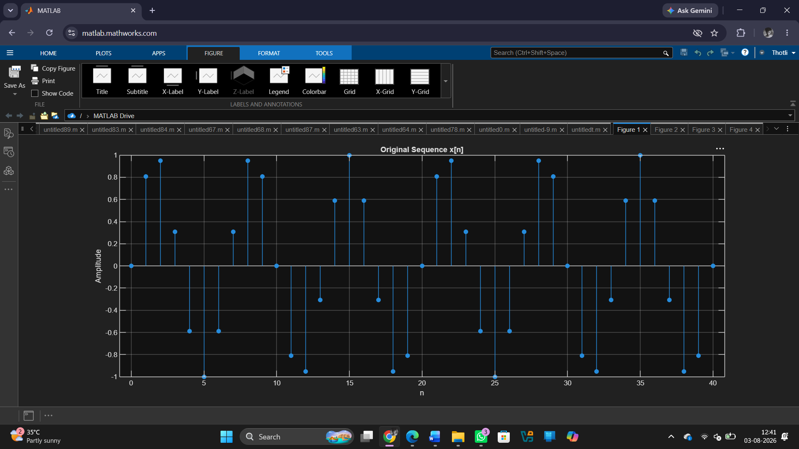

Fig 2
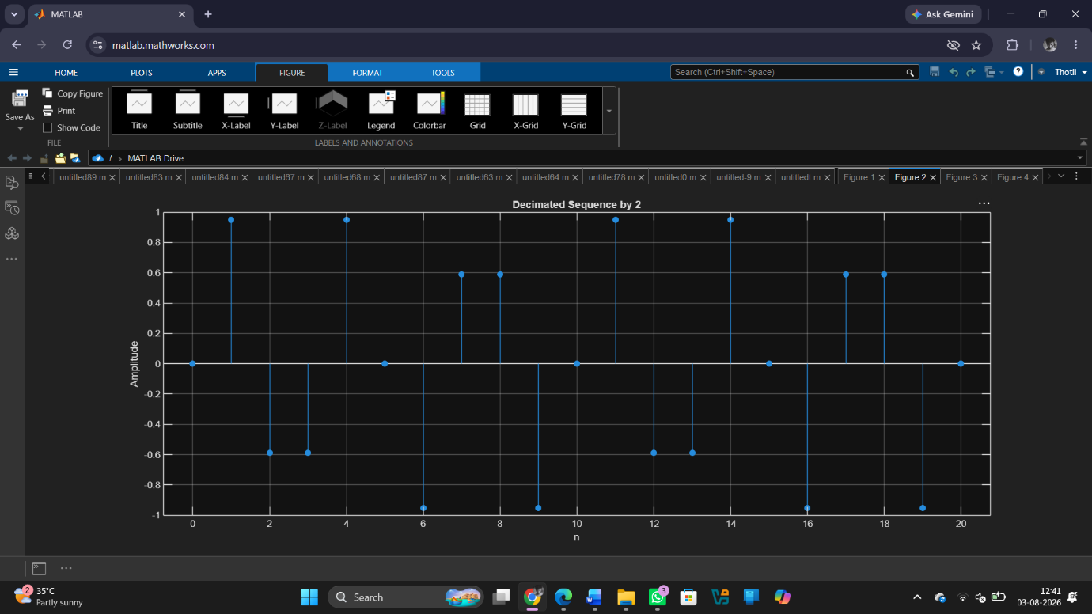

Fig 3
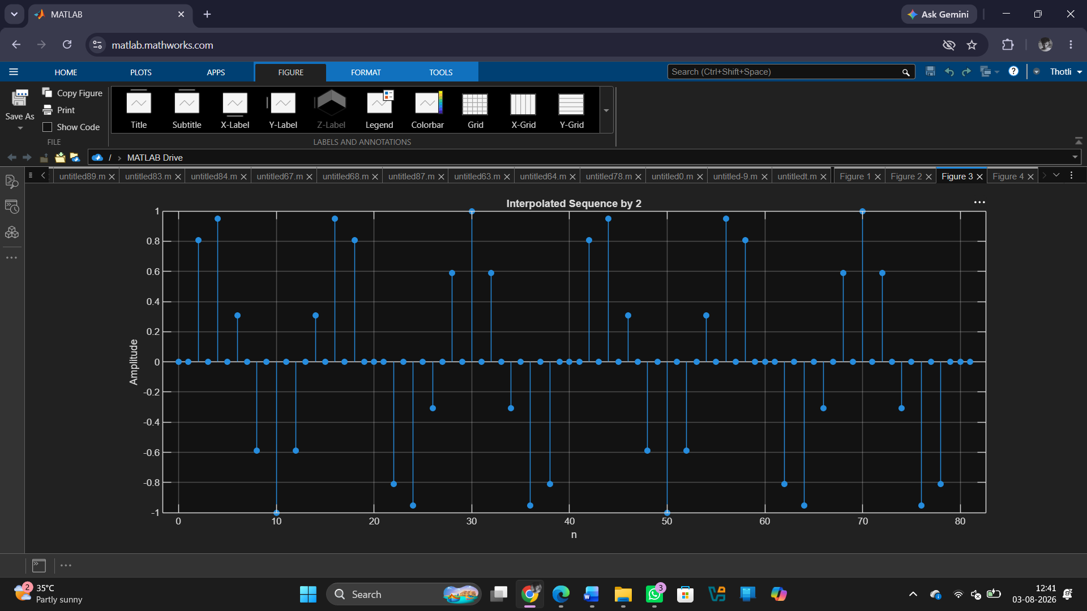

Fig 4
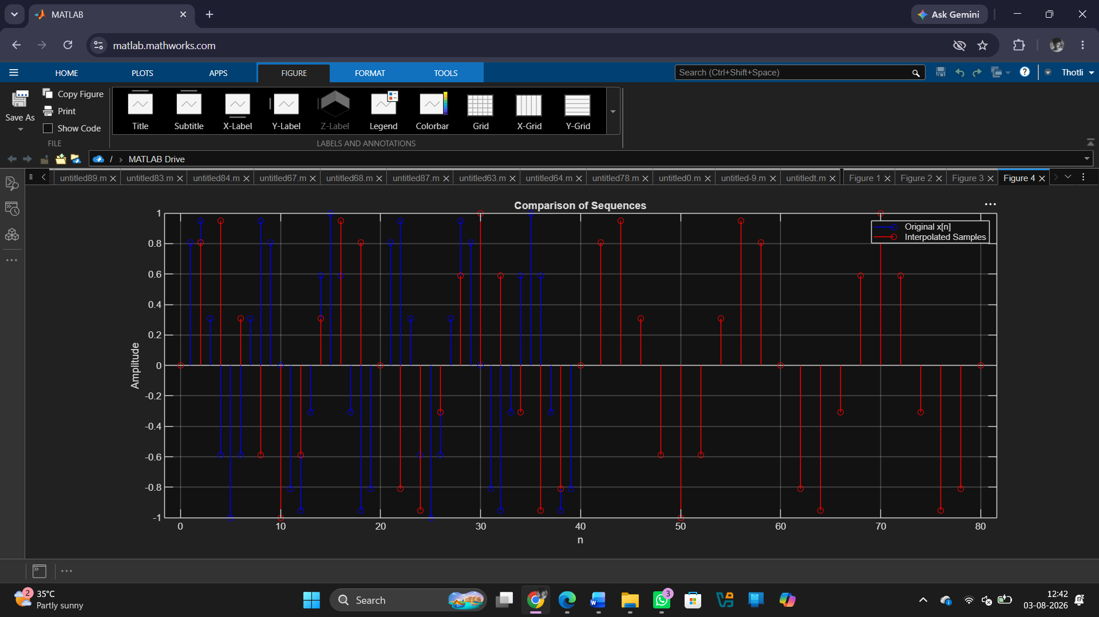
Result
1. A discrete-time sinusoidal sequence was successfully generated for multirate processing. 2. The discrete-time sequence was successfully decimated by a factor of 2, reducing the number of samples and the sampling rate.
3. The discrete-time sequence was successfully interpolated by a factor of 2, increasing the number of samples and the sampling rate.
4.The effects of down sampling and up sampling were successfully analysed by comparing the original, decimated, and interpolated signals.

